The **Downtown Appalachia Redevelopment Initiative** will offer a nationally recognized training on Main Street – Mixed Use Real Estate Finance from the **National Development Council (NDC)** on **March 31 - April 2 in Charleston, WV.**

Small cities and urban neighborhoods are at their best when their historic Main Street districts pulse with uses and activities that bring a community alive: residential, retail, entertainment, services, and public spaces.  Older districts have special opportunities for adaptive reuse—with buildings that are ideally suited to multiple uses (retail/office, residential/retail, etc.) in one structure.  Understanding how to finance mixed-used development as a way to catalyze Main Street, energizing it with shopping, dining, culture, and entertainment is critical for communities.  This course explores debt, equity and public/private financing tools available for Main Street redevelopment. Focus on: Mixed-Use Development Challenges, Mixed Financing, Taxes & Real Estate Development, and Financing Tools. **A course overview webinar will be held on February 6 – register** [**here**](https://nationaldevelopmentcouncil.asapconnected.com/classdetail.aspx?org=1364&pk=1636294)**.**

Applicants must be active in central Appalachia, with a priority on those working on West Virginia-based projects. Multiple applicants per organization are welcome. This course is provided to *approved* applicants free of charge (normally $1,375) thanks to sponsorship from **United Bank** and the Downtown Appalachia Redevelopment Initiative. **Space is limited.**

Lunches will be provided; other meals and lodging will be at the expense of the applicant; we will reserve a block of hotel rooms, details to come. If you receive an invitation to attend the course and the cost of travel is a significant barrier, please contact us, as travel scholarships may be made available on a limited basis.

Please submit the enclosed application and/or inquires to Downtown Appalachia Program Lead Ray Moeller at [raymond.moeller@mail.wvu.edu](mailto:raymond.moeller@mail.wvu.edu) (304-293-0390). **Applications are due via email Friday, February 21.** Approved applicants will be notified by Friday, February 28.

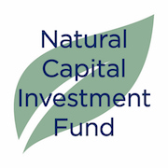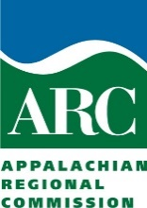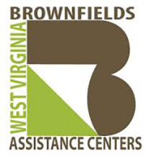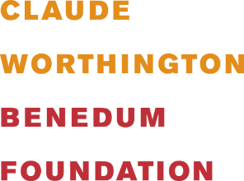

1. **Applicant**

1. Applicant Name:

1. Applicant Title & Company:

1. Applicant Email Address:

1. Applicant Telephone Number(s):
2. Applicant Location (City, State):
3. Service Area (please list relevant cities, counties, or states):

1. Applicant Role (active or emerging developer/property owner, consultants, economic development professional, community champion etc.):
2. Applicant Focus (mixed-use, commercial, affordable/low income housing, economic development, etc):
3. **Experience**

1. Describe your real estate activities and development experience, including the number of years you have been involved in real estate [you may attach information, e.g. CV]:
2. List other real estate related trainings you have attended or note if this will be your first related training experience:
3. Rate your skill level/knowledge of the following content on a scale from 1 (novice) to 5 (expert):
   1. Real estate project development process:
   2. Real estate funding and finance:
   3. Real estate construction:
   4. Real estate operations & management:
   5. Historic Tax Credits/Rehabilitation Tax Credits:
   6. Low-Income Housing Tax Credits:
4. What percentage of your work time do you estimate is directly related to real estate development activities?
5. Why have you decided to apply for this training; how do you expect this training will impact your development activities or job?
6. Briefly describe your upcoming real estate business/organizational plans and real estate project pipeline:
7. **Logistics**
8. Will you be able to attend all 3 days of the training, in their entirety (Tuesday – Thursday, 9:00 am – 4:00 pm)?
9. How did you learn about this training?

***

**Thank you for your interest in this opportunity!**

The Downtown Appalachia Redevelopment Initiative is a partnership between   
Natural Capital Investment Fund (NCIFund) and the WV Brownfields Assistance Center at WVU. Learn about the Initiative [here](https://ncifund.org/news/news-releases/89-new-grant-supports-west-virginia-downtown-redevelopment); contact Program Lead Ray Moeller at   
304-293-0390 or [raymond.moeller@mail.wvu.edu](mailto:raymond.moeller@mail.wvu.edu) for more information.